Preparation before installation
The ﬂooring materials are removed from packaging at least 48 hours prior to installation, and allowed to condition in the room where the installation is to take place. The room temperature must be between 64-81°F(18-27°C) prior and during installation. Separation is required for areas larger than 100 m² and/or longer than 10m.
All subfloors should be solid, dry (maximum moisture content 2.5% - CM method), smooth and level (1.2 m length 2 mm height difference), clean, dust free, no cracks and grease. The irregular surface should be leveled before installing the floor. Please consult an expert if necessary.
Install on the surface of paved tiled or wooden floors, consolidate and repair unstable tiles.
For old vinyl, tarpaulin, textile or laminate flooring, demolish the old flooring first. If necessary, use new plaster on the floor to polish then finish dust absorption .
During installation, you should always leave a 5-8mm expansion gap between the walls.
The relative humidity of the room must be hold at 45-60% and the temperature is between 15-27 ̊C.
Confirm the starting point for installation, for Herringbone (the 3rd installation method), starting from the entrance of the room. Not recommended for using in rooms and areas exposed to prolonged sunlight.
To avoid sudden temperature changes when installing the floor, it is not recommended to install the floor on heated floor.
Color difference
色差
There may be slight color difference between some floor due to different production batches. Before installation, firstly, check the production date marked on the short side. If the date is different, it is recommended to open 2 to 3 boxes and mix different batches of floor, then color of the total installed floor is more natural.
Do not install the floor on a soft floor or a soft pad.
Do not install the floor where there is a risk of flooding, such as sauna, bathroom. This floor is waterproof, But you should not let stagnant water stay on the floor for a long time.

After installation, please must keep the air conditioning temperature between 10 ̊C and 35 ̊C. Too high or too low temperature can cause the floor to expand or contract, resulting in unacceptable visual defects on the floor.
Prepare the required installation tools: pencil, utility knife, tape measure / ruler, square ruler, saw, human pressure roller, pull back hook, hammer and rubber pestle.
Refer to the 3 kinds of most common installation methods below. Choose one according to your preferences. Method 3 is the simplest. We recommend that you add more than 10% of the floor to prevent wear and tear.
Form | Classic version | Special 1 | Method NO.
opposite angles | 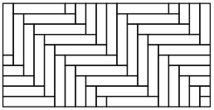 | 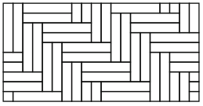 | 1
disperse | 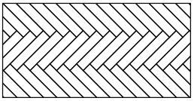 | 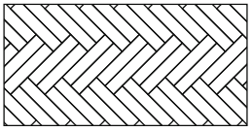 | 2
tradition | 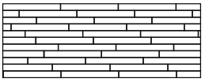 |  | 3

Prepare
Note: There’s letters "A" or "B" on the back of each floor. There are the same number of A floors and B floors in each box. Pay attention to the mark and install in pairs.
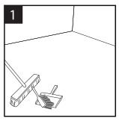  The subfloor must be completely flat, level, dry, clean and sturdy. Carpet, nail or glue residue must be removed. | 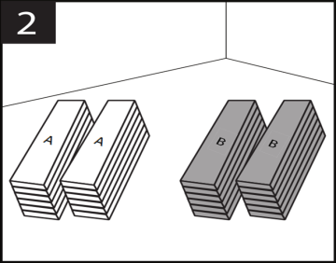  First, divide the A and B floors into two separate stacks. This is easier to distinguish when the floor is cut and some of the markings are not visible.
Method 1
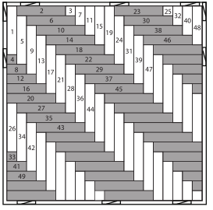
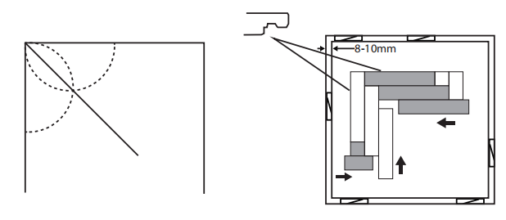
Draw a 45° line to align the floor. Please use a ruler and a pencil to mark two semicircles of the same radius on the ground and draw a line from the corner to the intersection of the two halves. During installation, put a wedge in the place of each 20-50cm along the wall, for leaving a 5-8mm expansion gap between the walls.
Starting from the left side of the room entrance. The first plank is with A mark. The 2nd plank is with B mark. Lock 1st plank with 2nd plank as per this image. Other planks are also refer to this image.

Cutting skills
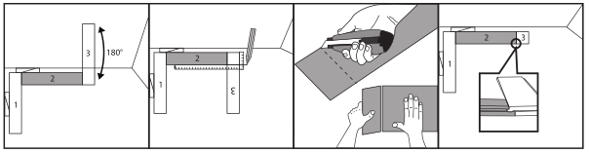
When need to cut the plank, such as 3rd plank, 4th plank, and other planks along the wall, check the click first, confirm the click can be locked with planks next to it, that is to say this part is the correct part . Then mark the length, finally cut the plank, take the correct part to install on the floor.
Method 2
First determine the center between the two walls facing each other and draw a line on the floor perpendicular to the wall (if the size of the room allows, it is recommended to draw the line through the middle of the room). Wedge the wall every 20-50cm to leave a 5-8mm expansion gap in the wall.
Starting from the floor labeled "B" (A1), the tongue is facing the wall and 3 rows are installed in the order shown in the picture. Then slide the installed floor to the wall wedge and align the centerline with the image below (see “Cut Tips” at the bottom of the page). To fill the gap between the wall and the floor.
The missing floor is then inserted into the gap of the next wall in the sequence of images. Remember to fill the gaps on both sides each time you completely install a new line.
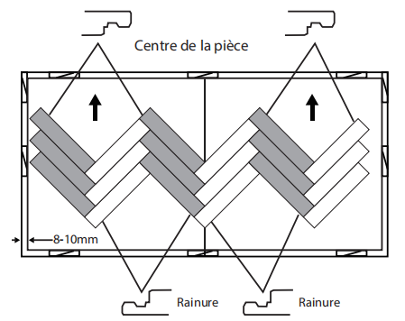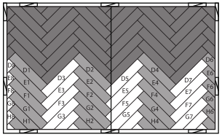
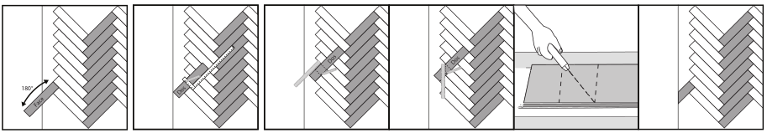
Cutting skill

- When reaching the wall, remove the floor to be cut and place it on top of the floor to make it fit the width (5-8mm from the wall). Rotate the floor 180° and take a square to draw the line.
- Mark the floor as shown.
- Draw a line at the distance of 149 mm from the marked line, as shown in the figure above. Draw a line between the two points you just marked and cut the floor along the line.
- Also can use pencils and rulers to measure excess parts, mark the floor and cut with a utility knife.
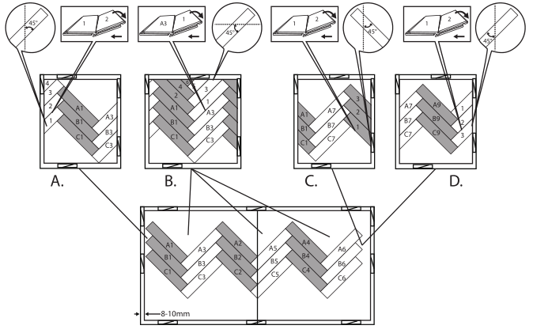
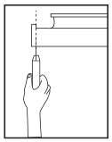
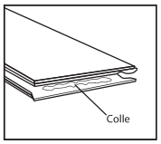
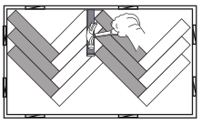
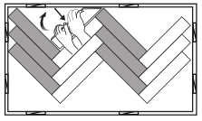
The following steps only apply to B.C.D.
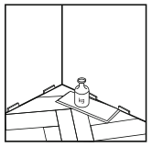

- After cutting the floor at a certain angle, cut the groove on the short side of the floor (as shown)
- Add PVA glue to the newly cut gap. Always wipe off any excess glue from the floor surface with a damp cloth.
- Installing the plank at an angle 45°.
- Use the floor pull hook and gently tap the floor against the wall.
- After filling the gap, place the weight on the floor where glue has been applied to ensure optimal fixing
Method 3
This method involves lining the floors in a row, called the traditional method.
This product is designed for "V-shaped". Therefore, there are two different degrees (A and B), but they can also be installed in a conventional manner.
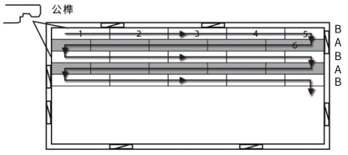
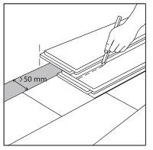
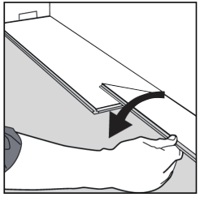
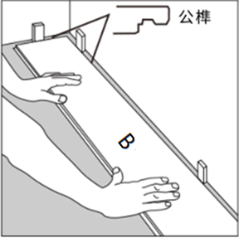

1. Rest the first floor (B) against the wall. Wedge the wall every 20-50 cm to leave a 5-8 mm expansion gap in the wall.
2. Place the second floor (B) at the end of the first row as the first one. Put the short edge close to the ground and put it vertically.
3. For subsequent lines, use (B) floor and (A) floor alternately, but be sure to offset the edge of the floor from the edge at the end of the previous row by at least 300mm.
Last row
The floor to be installed is accurately superimposed on the last row. Then use the third floor to be stacked on the wall, draw a line on the installed floor, then cut and install. The last line must be larger than 50 mm wide, otherwise it is recommended to use glue to assist in the last row.
Cutting skill
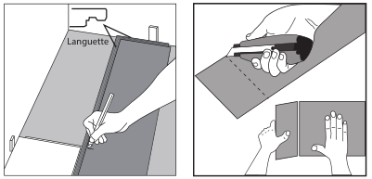
Using a knife and straight edge, cut the last piece of the row to size making sure that there is a 5 mm~8mm gap between the end of the row and the wall. Mark the cutting line, use a square and a utility knife, cut the surface of the floor and separate the excess floor by hand, the floor will naturally separate and then install.
Installation skills
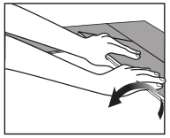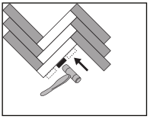
Move the short side closer to the ground plate to be vertical. Start the second row by gently clicking the tongue into the groove holding the plank at an angle (approximately 45°). Use a spacer and a small hammer or rubber hammer to gently tap the floor of the previous row to ensure it is in place.
Disassembly
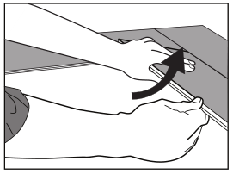
To disassemble, simply pick up the floor one by one in the reverse order of installation.

Finishing the Job:
Inspect your work, as it will cost you more if you have to come back to do a repair later. Replace original baseboards, or install matching hardwood baseboard. Install matching transitions as needed or recommended by your dealer or installer. It is not recommended or necessary to seal this floor after installation. Protect your floor from scratches by using felt pads on chair legs or furniture feet. Plastic rollers/castors can damage your flooring; if necessary try to replace with softer rubber wheels/ castors. When moving heavy items like refrigerators, use at least two sheets of plywood while moving (sliding the appliance from one sheet to the next) to protect the flooring against scratching and denting.

Floor Maintenance
Frequently moved furniture (chairs) should be equipped with felt pads to avoid scratching the floor and checked regularly. Heavy furniture and appliances should be equipped with non-staining large surface floor protectors. Furniture with castors or wheels must be easy swiveling, large surface non-staining and suitable for resilient floors. Do not use ball type castors as they can damage the floor.
Avoid exposure to extreme temperature fluctuations. The floor may not be installed in areas where it will occasionally be exposed to extremely high temperatures ( Saunas, verandas, etc.) Exceeding 45°C .Avoid exposure to long periods of direct sun-light causing the heat to accumulate on the floor surface exceeding 45°C.
Use walk-off mats at entrances to prevent dirt and grit from being tracked on to the floor. ( Ensure that the mat doesn’t have rubber backing)
Sweep or vacuum the floor regularly to remove loose dirt.
Do not use abrasive cleaners, bleach , wax or oil to maintain the floor
Clean up spills immediately.
Do not drag or slide heavy objects across the floor
Damp mop as needed using clean water and a diluted floor cleaner. Do not use harsh cleaners or chemicals on the floor.

